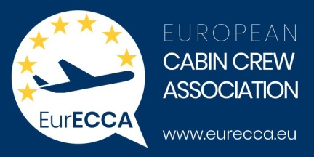

EurECCA ● Rue du Commerce 20-22 ● B-1000 Brussels

Ms. Adina Vălean

European Commissioner for Transport

Rue de la Loi 200

B-1049 Brussels

Belgium

Copy to:

Mr. Henrik Hololei

Director-General

Directorate-General for Mobility and Transport

Per email only

Brussels, 17 May 2021

Subject: Support of the current draft Standard on Cabin Air Quality produced by a diverse set of stakeholders from the CEN TC436 Committee.

Dear Commissioner Vălean,

EurECCA, the European Cabin Crew Association, support the the current draft Standard on Cabin Air Quality, that was produced by a diverse set of stakeholders from the CEN TC436 Committee.

EurECCA has noted the recent call by Frank Brehany, who is a European Citizen and an Independent Consumer Campaigner & Advocate, for European National Consumer Organisations to support the current draft standard on Cabin Air Quality.

EurECCA has also noted that the current draft Standard is subject to a second Public Enquiry. As part of that Enquiry, National Standards Bodies have been asked to answer the question: “Do you approve this draft as a European Standard?”. EurECCA notes that National Consumer Organisations are being encouraged to register a negative approval for the current draft through their National Standards Bodies; Frank Brehany is however countering such lobbying efforts by providing clear facts and encouraging them to provide their positive support for the benefit of EU Cabin Crew and Consumers.

EurECCA supports this initiative taken by Frank Brehany as we believe that this current draft Standard does indeed deliver important benefits to European Consumers, but, importantly, it also delivers real benefits to our Cabin Crew and other stakeholders, through its measured, sensible and proportionate requirements.

In our opinion this current draft Standard presents long overdue changes as to how the problem of Cabin Air Quality has been dealt with.

EurECCA calls on the European Commission to support this initiative with National Consumer Organisations, for those same Organisations to fully engage with the issues at hand, and to ensure that the benefits already achieved, are now delivered publicly for the benefit of all Cabin Crew and stakeholders.

Very kind regards

Annette Groeneveld Xavier Gautier

President Secretary General

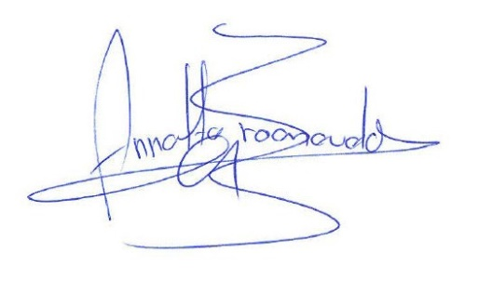



About EurECCA

Established in Brussels in 2014, the European Cabin Crew Association, EurECCA, represents, protects and develops the rights and needs of cabin crew all over Europe. It is composed of cabin crew unions from European Union Member States as well as accession and bordering states, and represents some 33,000 cabin crew accounting for 70% of all organised cabin crew in Europe. EurECCA has no political connections.

EurECCA’s work is mainly around cabin and passenger safety and cabin crew health and work and living conditions

<http://www.eurecca.eu/>